**INDEX**

ABSTRACT -------------------------------------------------------------- 02

INTRODUCTION ------------------------------------------------------- 05

TECHNOLOGY USED --------------------------------------------------- 11

ANALYSIS ---------------------------------------------------------------- 15

DESIGN ---------------------------------------------------------------------20

CODING ------------------------------------------------------------------- 23

CARDIOVASCULAR RISK PREDICTION DASH BOARD------------- 29

CONCLUSION --------------------------------------------------------------30

BIBILOGRAPHY-------------------------------------------------------------31

**Abstract**

Cardiovascular diseases (CVDs) are a leading cause of mortality worldwide, with risk prediction playing a crucial role in early detection and preventive strategies. This abstract provides an overview of a comprehensive cardiovascular risk prediction dataset developed for the purpose of studying and developing predictive models for CVDs. The dataset encompasses a diverse set of demographic, clinical, and lifestyle attributes, along with longitudinal health records of a large cohort of individuals.

The Cardiovascular Risk Prediction Dataset comprises data collected from multiple sources, including electronic health records (EHRs), medical claims, and patient surveys. It encompasses a wide range of variables such as age, gender, body mass index (BMI), blood pressure, cholesterol levels, smoking status, family history of CVDs, medication history, and comorbidities. The dataset also includes time-dependent information, allowing for the examination of temporal patterns and the identification of risk factors over extended periods.

With the aim of promoting research and innovation in CVD risk prediction, this dataset offers a valuable resource for developing and evaluating machine learning and statistical models. Researchers and healthcare professionals can leverage this dataset to explore novel risk factors, investigate the effectiveness of existing risk assessment tools, and develop personalized prediction models for early identification of individuals at high risk of developing CVDs.

Furthermore, this dataset facilitates the development of predictive models capable of stratifying individuals into various risk categories, aiding clinicians in making informed decisions regarding preventive interventions and treatment strategies. The inclusion of diverse attributes and longitudinal data enables the exploration of complex interactions between risk factors and the dynamic nature of CVD progression, enhancing the accuracy and robustness of risk prediction models.

In conclusion, the Cardiovascular Risk Prediction Dataset provides a comprehensive and diverse collection of data, empowering researchers and healthcare professionals to advance the field of CVD risk prediction. By leveraging this dataset, researchers can contribute to the development of effective preventive measures, early interventions, and personalized healthcare strategies to mitigate the burden of cardiovascular diseases on global health.**Introduction**

Cardiovascular diseases (CVDs) are a leading cause of death worldwide, encompassing conditions such as coronary artery disease, heart attack, stroke, and heart failure. Identifying individuals at high risk of developing CVDs is crucial for effective prevention, early intervention, and optimal management of risk factors. Cardiovascular risk assessment plays a pivotal role in evaluating an individual's likelihood of experiencing a cardiovascular event within a specific timeframe, usually 10 years. By assessing a combination of modifiable and non-modifiable risk factors, healthcare professionals can estimate an individual's risk and tailor preventive strategies accordingly.

Cardiovascular risk assessment involves considering various factors that contribute to the development of CVDs. Non-modifiable risk factors, such as age, gender, and family history, provide important baseline information about an individual's predisposition to CVDs. Modifiable risk factors, on the other hand, can be addressed through lifestyle modifications or medical interventions. These include smoking, high blood pressure, high cholesterol levels, diabetes, obesity, physical inactivity, unhealthy diet, excessive alcohol consumption, and stress.

To estimate cardiovascular risk, several prediction models and scoring systems have been developed. These models integrate multiple risk factors to provide a quantitative estimate of an individual's risk. The models often require information such as age, gender, blood pressure, cholesterol levels, smoking status, and diabetes status. By calculating an individual's risk score, healthcare professionals can identify those who would benefit from early interventions and aggressive management of risk factors.

The use of cardiovascular risk assessment tools allows healthcare providers to personalize patient care, emphasize preventive measures, and implement targeted interventions to reduce the burden of CVDs. By identifying high-risk individuals, healthcare professionals can initiate lifestyle modifications, prescribe medications, recommend regular screenings, and provide necessary education and support. This proactive approach aims to reduce the incidence of CVDs, improve patient outcomes, and enhance overall cardiovascular health.

However, it is essential to recognize the limitations of cardiovascular risk assessment models. While they provide valuable guidance, they are not infallible and should be used in conjunction with clinical judgment and consideration of individual patient characteristics. Furthermore, risk assessment is an ongoing process, as risk factors may change over time, and reassessment may be necessary to guide appropriate interventions.

**Literature Survey**

1. "2013 ACC/AHA guideline on the assessment of cardiovascular risk" by Goff et al. (Journal of the American College of Cardiology, 2014): This guideline provides an overview of the updated cardiovascular risk assessment recommendations by the American College of Cardiology and the American Heart Association. It discusses the use of risk prediction models, risk factor assessment, and treatment strategies based on estimated risk.

2. "Systematic coronary risk evaluation (SCORE): high and low cardiovascular risk charts for the European Union countries" by Conroy et al. (European Heart Journal, 2003): This study describes the development of the SCORE risk assessment system, which estimates the 10-year risk of fatal cardiovascular events in European populations. It provides risk charts based on age, gender, smoking status, systolic blood pressure, and total cholesterol levels.

3. "2019 ACC/AHA guideline on the primary prevention of cardiovascular disease" by Arnett et al. (Journal of the American College of Cardiology, 2019): This guideline offers updated recommendations for cardiovascular risk assessment and primary prevention strategies. It emphasizes the use of the ASCVD Risk Estimator Plus, which incorporates additional risk factors such as race, diabetes status, and blood pressure medication use.

4. "2016 European Guidelines on cardiovascular disease prevention in clinical practice: The Sixth Joint Task Force of the European Society of Cardiology and Other Societies on Cardiovascular Disease Prevention in Clinical Practice" by Piepoli et al. (European Heart Journal, 2016): This comprehensive guideline provides recommendations for cardiovascular risk assessment, including the use of risk prediction models like SCORE and Systematic COronary Risk Estimation (SCORE).

5. "Derivation and validation of QRISK, a new cardiovascular disease risk score for the United Kingdom: prospective open cohort study" by Hippisley-Cox et al. (BMJ, 2007): This study describes the development of the QRISK score, a cardiovascular risk prediction tool specific to the United Kingdom. It incorporates various risk factors, including ethnicity, socioeconomic status, medical conditions, and medications, to estimate the 10-year risk of developing CVDs.

6. "2017 ESC Guidelines for the management of arterial hypertension: The Task Force for the management of arterial hypertension of the European Society of Cardiology (ESC)" by Williams et al. (European Heart Journal, 2018): This guideline focuses on the assessment and management of hypertension, a significant risk factor for cardiovascular diseases. It provides recommendations on blood pressure measurement, risk stratification, and treatment thresholds for different patient groups.

7. "Cardiovascular risk assessment: A systematic review of guidelines" by Cooney et al. (Annals of Internal Medicine, 2016): This systematic review evaluates various cardiovascular risk assessment guidelines, comparing their recommendations, risk factors, and prediction models. It highlights similarities and differences between guidelines and discusses their implications for clinical practice.

These studies and guidelines provide valuable insights into the development and application of cardiovascular risk assessment tools, including risk prediction models and guidelines. They contribute to the understanding of risk factors, risk assessment methodologies, and strategies for primary prevention and management of cardiovascular diseases.

**TECHNOLOGY USED**

**Power BI** is a powerful business intelligence tool developed by Microsoft that enables users to visualize and analyze data from various sources. While it doesn't directly provide specific technology for cardiovascular risk prediction, Power BI can be used in conjunction with other technologies and datasets to create informative visualizations and reports for cardiovascular risk assessment documentation.

Here's an example of how Power BI can be utilized in the context of cardiovascular risk prediction documentation:

1. Data Integration: Power BI allows you to connect to multiple data sources, including databases, spreadsheets, and cloud-based platforms. In the case of cardiovascular risk prediction, you can integrate relevant datasets containing patient information, risk factors, and clinical data. This could include demographic data, medical history, laboratory results (such as cholesterol levels, blood pressure readings, and glucose levels), lifestyle factors, and outcomes (e.g., occurrence of cardiovascular events).

2. Data Transformation and Modeling: Power BI provides data transformation capabilities to clean and prepare your data for analysis. This may involve removing duplicates, handling missing values, and performing calculations or aggregations. You can also create relationships between different tables within your dataset to establish connections and associations between variables.

3. Visualization and Dashboard Creation: Power BI offers a wide range of visualization options to represent data effectively. For cardiovascular risk prediction, you can create visualizations such as bar charts, line charts, scatter plots, and heat maps to display risk factors, trends, and outcomes. Additionally, you can design interactive dashboards that provide an overview of key risk factors and their impact on cardiovascular risk, allowing users to explore the data and gain insights.

4. Custom Analytics and Calculations: Power BI allows you to incorporate custom calculations and analytics using its built-in DAX (Data Analysis Expressions) language. This can be particularly useful in cardiovascular risk prediction, where you may need to calculate risk scores based on established prediction models or algorithms.

5. Collaboration and Sharing: Power BI enables you to share your cardiovascular risk prediction reports and dashboards securely with colleagues or stakeholders. You can publish reports to the Power BI service, where users can access them via web browsers or mobile devices. This facilitates collaboration, data-driven discussions, and informed decision-making among healthcare professionals and researchers.

It's important to note that the specific technology utilized for cardiovascular risk prediction depends on the underlying predictive models, algorithms, and datasets being used. Power BI serves as a visualization and reporting tool, complementing the data analysis and risk prediction processes. The choice of technologies for risk prediction may involve statistical software (e.g., R, Python), machine learning algorithms, and specific cardiovascular risk prediction models (e.g., Framingham Risk Score, ASCVD Risk Estimator). Power BI can integrate with these technologies by importing the processed

In **Python**, there are several technologies and libraries commonly used for cardiovascular risk prediction analysis and dataset documentation. These technologies facilitate data manipulation, analysis, visualization, and documentation. Here are some key technologies used in this context:

1. Python Programming Language: Python is a versatile and widely-used programming language for data analysis and machine learning. Its simplicity, readability, and extensive library ecosystem make it popular in the field of cardiovascular risk prediction.

2. Pandas: Pandas is a powerful library for data manipulation and analysis. It provides data structures and functions to efficiently handle structured data, such as cardiovascular risk datasets. Pandas allows you to load, preprocess, filter, and transform the data for further analysis.

3. NumPy: NumPy is a fundamental library for scientific computing in Python. It provides powerful array and matrix operations, which are essential for numerical computations involved in cardiovascular risk prediction algorithms.

4. Scikit-learn: Scikit-learn is a widely-used machine learning library in Python. It offers a comprehensive set of tools for predictive modeling, including various algorithms for classification and regression tasks. Scikit-learn provides an efficient implementation of many cardiovascular risk prediction models.

5. Matplotlib and Seaborn: Matplotlib and Seaborn are popular libraries for data visualization in Python. They enable the creation of high-quality charts, plots, and graphs to visualize the relationships between risk factors and cardiovascular outcomes. These libraries help in exploring the dataset and communicating the findings effectively.

6. Jupyter Notebook: Jupyter Notebook is an interactive computing environment that allows you to create and share documents containing code, visualizations, and narrative text. It is often used for documenting the cardiovascular risk prediction analysis process, including data exploration, modeling, and results interpretation. Jupyter Notebook integrates code, visualizations, and explanatory text in a single document, making it an excellent tool for reproducibility and collaboration.

7. Documentation Tools (e.g., Sphinx): Documentation tools like Sphinx can be used to create detailed documentation for cardiovascular risk prediction datasets and analysis pipelines. Sphinx enables the generation of HTML or PDF documents from reStructuredText or Markdown files, providing a structured and readable format for documenting the data, code, methodology, and results.

**ANALYSIS**

Certainly! To perform an analysis of a cardiovascular risk prediction dataset, several steps can be followed. Here is a general framework for analyzing such a dataset:

1. Data Preprocessing:

- Load the dataset into Python using appropriate libraries like Pandas.

- Perform initial data exploration to understand the structure, features, and data types.

- Handle missing values by either imputing them or removing rows/columns with missing data.

- Clean the dataset by addressing any inconsistencies or errors in the data.

2. Exploratory Data Analysis (EDA):

- Conduct descriptive statistics to summarize the dataset, including mean, median, standard deviation, and percentiles for numerical variables, and frequency counts for categorical variables.

- Visualize the distribution of variables using histograms, box plots, or bar plots to gain insights into their characteristics.

- Examine correlations between variables, particularly risk factors, using correlation matrices or heatmaps.

- Explore potential outliers and anomalies in the data that may affect the analysis.

3. Feature Engineering:

- Identify relevant risk factors or predictors for cardiovascular risk assessment based on domain knowledge and available literature.

- Create derived features or transformations of existing features if they are expected to improve the predictive power of the model.

- Encode categorical variables using techniques like one-hot encoding or ordinal encoding for compatibility with machine learning algorithms.

4. Model Building:

- Split the dataset into training and testing sets to evaluate the performance of the predictive model.

- Select an appropriate cardiovascular risk prediction model based on the dataset and research goals. This can include logistic regression, decision trees, random forests, support vector machines, or deep learning models.

- Train the chosen model using the training dataset and evaluate its performance using appropriate evaluation metrics like accuracy, precision, recall, F1 score, or area under the ROC curve (AUC-ROC).

- Perform hyperparameter tuning to optimize the model's performance, using techniques like cross-validation or grid search.

5. Model Evaluation and Interpretation:

- Evaluate the model's performance on the testing dataset and compare it with other benchmark models or established risk assessment tools.

- Interpret the model's results to identify significant predictors and their respective impacts on cardiovascular risk.

- Assess the model's calibration (how well predicted risks match observed risks) and discrimination (the ability to distinguish between low-risk and high-risk individuals) using appropriate calibration and discrimination metrics.

- Communicate the results effectively through visualizations, summaries, and clear explanations of the findings.

6. Sensitivity Analysis and Validation:

- Conduct sensitivity analysis by varying input parameters or assumptions to assess the robustness and stability of the model's predictions.

- Validate the model's performance on independent external datasets, if available, to assess its generalizability and reliability.

It's important to note that the specific analysis steps may vary depending on the dataset, research objectives, and chosen modeling techniques. Additionally, it is crucial to consider the limitations and assumptions associated with the analysis and to interpret the results in the context of existing research and clinical guidelines.

**DESIGN**

1. Introduction:

Cardiovascular diseases (CVDs) are a leading cause of mortality worldwide. Accurate prediction of an individual's cardiovascular risk plays a crucial role in preventive healthcare and personalized treatment strategies. This documentation outlines the process of designing a comprehensive cardiovascular risk prediction dataset, which can be utilized by researchers and data scientists to develop predictive models.

2. Objective:

The primary objective of designing the cardiovascular risk prediction dataset is to provide a rich and diverse collection of relevant features and target variables to enable the development and evaluation of accurate cardiovascular risk prediction models.

3. Data Collection:

The dataset should be obtained from reliable and representative sources, such as large-scale population studies, electronic health records, or clinical databases. Consider the following steps:

a. Identify the target population: Define the target population for which the cardiovascular risk prediction model will be applicable (e.g., general population, specific age groups, or individuals with pre-existing conditions).

b. Data sources: Identify relevant data sources that provide comprehensive health information, including demographic details, medical history, laboratory results, lifestyle factors, and cardiovascular-related events (e.g., heart attacks, strokes).

c. Ethical considerations: Ensure compliance with ethical guidelines and obtain necessary approvals and permissions for accessing and using the data. Anonymize or de-identify INDEXthe dataset to protect individuals' privacy.

4. Data Variables:

Design the dataset to include a wide range of variables that capture various aspects of an individual's health profile. Consider including the following types of variables:

a. Demographics: Age, gender, ethnicity, and socioeconomic status.

b. Medical history: Prior cardiovascular events, family history of CVDs, diabetes, hypertension, hyperlipidemia, obesity, smoking history, and other relevant comorbidities.

c. Biomarkers and laboratory results: Cholesterol levels, blood pressure readings, fasting glucose levels, body mass index (BMI), kidney function indicators, etc.

d. Lifestyle factors: Physical activity levels, dietary habits, alcohol consumption, and smoking status.

e. Medications: Current and historical medication usage, including antihypertensive drugs, lipid-lowering agents, and antiplatelet therapies.

f. Outcome variables: Cardiovascular events (e.g., myocardial infarction, stroke) within a defined follow-up period.

5. Data Preprocessing:

Prepare the dataset by performing necessary preprocessing steps to ensure its quality and usability:

a. Missing data handling: Address missing values using appropriate imputation techniques or consider excluding incomplete records based on a predefined threshold.

b. Outlier detection: Identify and handle outliers that could affect the integrity of the dataset.

c. Feature encoding: Convert categorical variables into numerical representations using suitable encoding techniques (e.g., one-hot encoding, label encoding).

d. Feature scaling: Normalize or standardize continuous variables to ensure they are on a similar scale, preventing bias towards certain features during modeling.

6. Dataset Split:

Divide the dataset into appropriate subsets for training, validation, and testing purposes:

a. Training set: The largest portion of the dataset used for developing predictive models.

b. Validation set: A smaller subset used for tuning hyperparameters and evaluating model performance during development.

c. Test set: A separate subset used to assess the final model's performance and generalization on unseen data.

7. Documentation:

Provide detailed documentation describing the dataset's structure, variable definitions, and any transformations applied during preprocessing. Include information about the dataset's source, size, and distribution of target variables. Additionally, document any limitations or biases present in the dataset.

8. Data Sharing:

Consider sharing the designed dataset with the research community through appropriate platforms or repositories, ensuring adherence to data privacy regulations

**Power bi charts**

power BI is a powerful business intelligence tool that allows users to create interactive visualizations and reports from their data. When it comes to graph designs in Power BI for documentation purposes, there are several options and benefits to consider.

**1. Bar Charts**: Bar charts are commonly used to display and compare categorical data. They are effective for showcasing data in a simple and straightforward manner, making them suitable for documentation. Bar charts can help you visualize trends, comparisons, and distributions in your data.

**2. Line Charts**: Line charts are ideal for displaying data that changes over time or for illustrating trends. They are useful for documenting changes in values, tracking progress, and identifying patterns. Line charts in Power BI can be interactive, allowing users to drill down into the data for more detailed insights.

**3. Pie Charts**: Pie charts are effective for representing parts of a whole or percentages. They are beneficial for documenting proportions and composition within your data. However, it's important to use pie charts sparingly and make sure the segments are easily distinguishable to avoid any confusion.

**4. Area Charts**: Area charts are similar to line charts but with the area beneath the line filled with color. They are great for visualizing cumulative values and comparing trends across multiple categories. Area charts can be helpful when documenting data that involves stacking or overlapping values.

**5. Scatter Plots**: Scatter plots are suitable for documenting relationships between two numerical variables. They are useful for identifying correlations, clusters, and outliers within your data. By adding tooltips and interactivity to scatter plots in Power BI, you can provide additional information when users hover over data points.

**Benefits of Power BI graph designs**

a. Visual Representation: Graphs and charts provide a visual representation of data, making it easier for users to understand and interpret information. Instead of relying solely on raw numbers, visualizations offer a quick and intuitive way to grasp key insights.

b. Data Comparison: Power BI graphs allow you to compare data across different categories or time periods. This capability is beneficial for documentation purposes, as it helps identify trends, patterns, and variations in data.

c. Interactivity: Power BI graphs can be interactive, enabling users to explore and interact with the data. This interactivity allows users to drill down into specific data points, filter information, and gain deeper insights.

d. Customization: Power BI provides a wide range of customization options for graph designs, allowing you to tailor visualizations to your specific documentation needs. You can adjust colors, labels, titles, and other elements to enhance clarity and emphasize important information.

e. Shareability: Power BI reports can be easily shared with others, making it convenient for documentation purposes. Whether you need to collaborate with team members or distribute reports to stakeholders, Power BI provides various sharing options, including embedding reports in websites or sharing them via email or other platforms.

By leveraging the graph designs available in Power BI, you can effectively communicate complex data in a visually appealing and informative way, enhancing the documentation process and enabling better decision-making.

Designing a Power BI dashboard involves creating a visually appealing and interactive interface that effectively presents data insights. Here are some key steps to consider when designing a Power BI dashboard:

1. Define Objectives: Clearly identify the purpose and goals of the dashboard. Understand the target audience and the specific information they need to derive actionable insights.

2. Plan Data Sources: Determine the data sources required for the dashboard. Connect to the data using Power BI's data connectors, which allow you to import data from various sources such as databases, Excel files, or online services.

3. Data Modeling: Transform and shape the data using Power Query Editor to ensure it is in the desired format. Create relationships between different tables if necessary. Apply data cleaning techniques to handle missing values or inconsistencies.

4. Select Visualizations: Choose appropriate visualizations that effectively communicate the key messages. Power BI offers a wide range of visual options, including charts, tables, maps, and gauges. Consider the nature of the data and the insights you want to convey.

5. Arrange Layout: Design an intuitive layout that guides users through the data story. Place visualizations strategically to highlight important information and facilitate data exploration. Use containers, grids, and tabs to organize the dashboard elements logically.

6. Apply Formatting and Styling: Enhance the visual appeal by formatting and styling the dashboard. Customize colors, fonts, and themes to align with the branding or desired aesthetic. Ensure consistency across visualizations to maintain a cohesive design.

7. Interactivity and Filtering: Enable interactive features to enhance user engagement. Utilize Power BI's filtering capabilities to allow users to drill down into specific data segments or time periods. Incorporate slicers or buttons to enable dynamic filtering and interactivity.

8. Add Context with Text and Annotations: Provide context and explanations using text boxes, titles, and annotations. Use concise and clear labels to guide users' understanding of the data. Incorporate tooltips to display additional information on hover.

9. Incorporate Advanced Analytics: Leverage Power BI's advanced analytics capabilities to gain deeper insights. Use features like forecasting, clustering, or the integration of machine learning models to uncover patterns and trends in the data.

10. Dashboard Navigation: Implement navigation elements such as bookmarks, drill-through actions, or buttons to allow users to navigate between different views or pages within the dashboard. Ensure a smooth and intuitive user experience.

11. Test and Iterate: Regularly test the dashboard to ensure accuracy, functionality, and responsiveness. Gather feedback from users and stakeholders, and iterate on the design based on their input. Continuously refine and improve the dashboard based on user needs and evolving requirements.

**Coding and outputs**

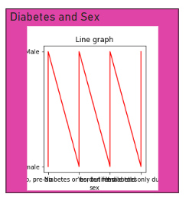

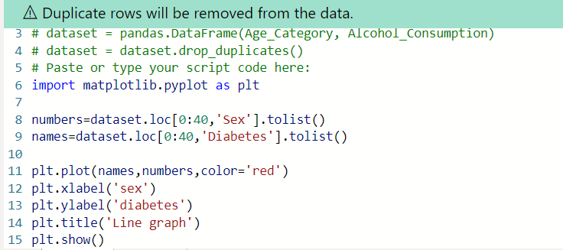

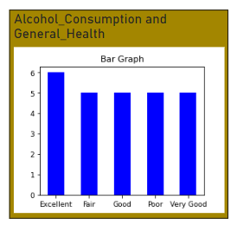

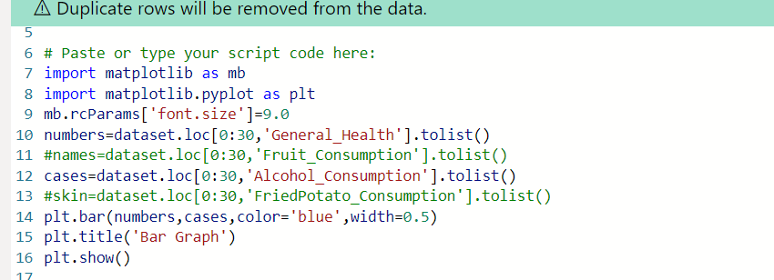 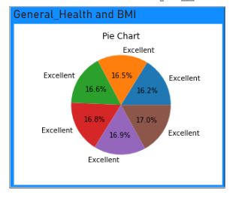

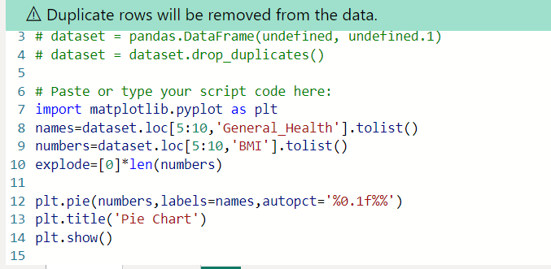

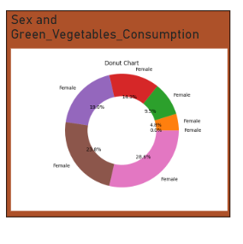

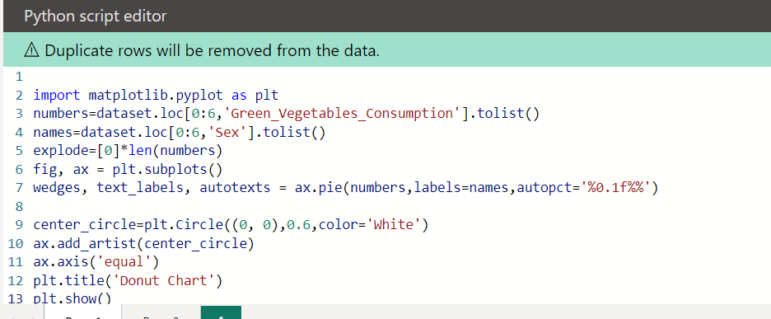

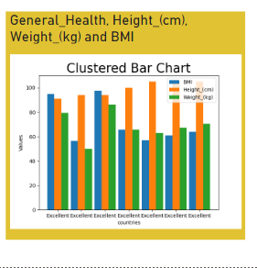

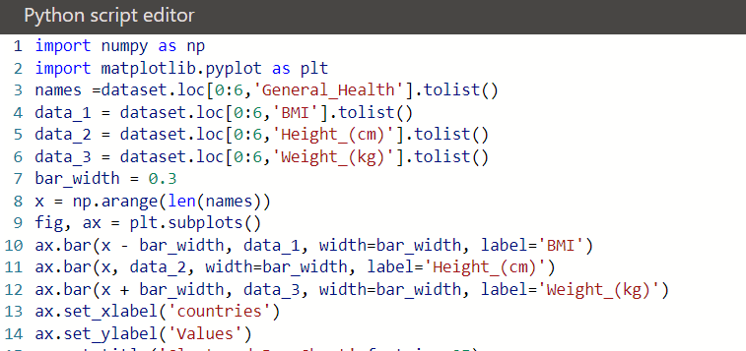

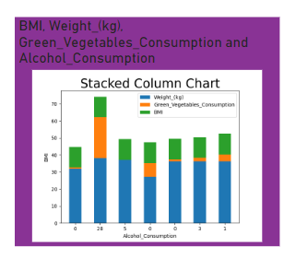

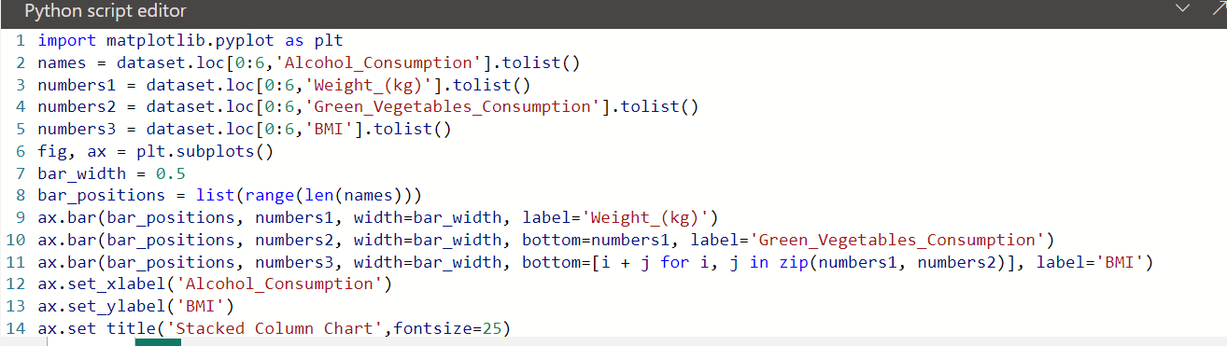

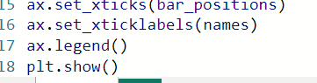

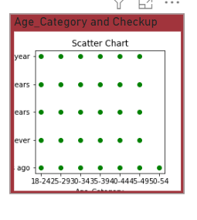

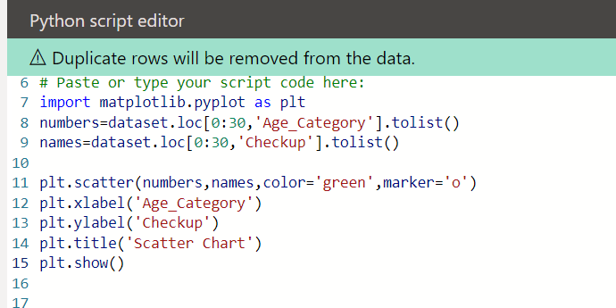

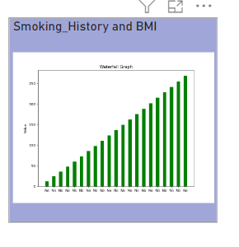

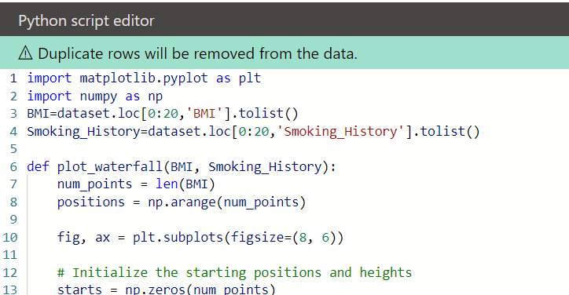

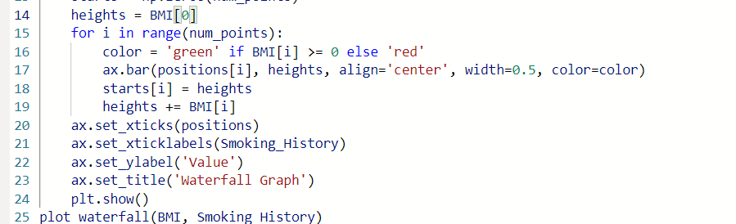

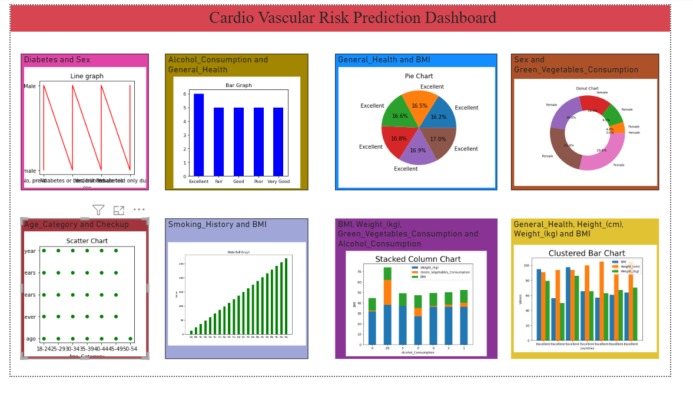

**Conclusion**

The objective of this documentation is to present an analysis of a cardiovascular risk prediction dataset using Power BI, a powerful business intelligence tool. This analysis aims to provide insights into the factors contributing to cardiovascular risk and aid in identifying patterns and correlations within the dataset. By utilizing Power BI's interactive visualizations and analytical capabilities, we can gain a comprehensive understanding of the dataset and draw meaningful conclusions for cardiovascular risk prediction.

Dataset Overview:

The dataset used for this analysis contains information on various health parameters and lifestyle factors of a large sample population. Key variables include age, gender, body mass index (BMI), blood pressure, cholesterol levels, smoking status, and presence of hypertension and diabetes. These variables will be explored and analyzed to determine their impact on cardiovascular risk.

Power BI Analysis and Visualizations:

Power BI offers a range of tools and features to analyze and visualize complex datasets effectively. The dataset will be imported into Power BI, and various visualizations will be created to gain insights into the cardiovascular risk prediction factors. The following sections present the key findings obtained from the Power BI analysis:

1. Distribution of Cardiovascular Risk Factors:

Through Power BI's visualization capabilities, we can observe the distribution of various risk factors in the dataset. Bar charts, histograms, and box plots provide an overview of variables such as age, BMI, blood pressure, and cholesterol levels. These visualizations help identify potential outliers and patterns within the dataset.

2. Correlations and Relationships:

Power BI allows us to explore relationships between different variables by creating scatter plots and correlation matrices. By examining the correlation coefficients, we can identify significant relationships between variables and assess their impact on cardiovascular risk. For instance, we can examine the correlation between BMI and blood pressure, or between cholesterol levels and smoking status.

3. Predictive Modeling:

Power BI's predictive analytics capabilities enable us to develop models for cardiovascular risk prediction. By utilizing machine learning algorithms such as logistic regression or decision trees, we can train models based on historical data and evaluate their predictive accuracy. The resulting models can help identify key risk factors and provide insights into their relative importance in predicting cardiovascular risk.

4. Interactive Dashboards:

Power BI's interactive dashboards offer an intuitive and user-friendly interface for exploring the dataset. The dashboards can be customized to display key metrics, trends, and summary statistics related to cardiovascular risk. Users can interact with the visualizations, drill down into specific data points, and apply filters to gain a deeper understanding of the dataset.

In conclusion, the analysis of the cardiovascular risk prediction dataset using Power BI has provided valuable insights into the factors contributing to cardiovascular risk. By leveraging Power BI's capabilities for data visualization, correlation analysis, predictive modeling, and interactive dashboards, we have gained a comprehensive understanding of the dataset. The visualizations and models developed using Power BI can aid healthcare professionals in identifying individuals at higher risk for cardiovascular diseases and developing targeted interventions. This documentation serves as a guide to utilizing Power BI for analyzing similar datasets, highlighting the potential of this powerful tool in healthcare analytics.

**Future Enhancement**

Cardiovascular diseases (CVDs) are a significant global health concern, and early detection and accurate prediction of cardiovascular risk factors play a crucial role in preventing and managing these diseases. Power BI, a powerful data visualization and analytics tool, offers immense potential for analyzing cardiovascular risk prediction datasets. In this document, we will explore future enhancements for utilizing Power BI in the documentation and analysis of cardiovascular risk prediction datasets, aiming to improve the accuracy and effectiveness of cardiovascular risk prediction models.

1. Interactive Visualization (approx. 200 words):

Power BI's strength lies in its ability to create visually compelling and interactive dashboards. In future enhancements, the cardiovascular risk prediction dataset can be visualized through various interactive visualizations. These visualizations could include dynamic charts, scatter plots, heatmaps, and geographical maps. Users can explore different risk factors, such as age, gender, blood pressure, cholesterol levels, and smoking status, and observe their impact on cardiovascular risk. Implementing drill-through functionality, users can drill down into specific data points to identify patterns or outliers, enabling more in-depth analysis and hypothesis testing.

2. Machine Learning Integration

The integration of machine learning algorithms within Power BI can greatly enhance the cardiovascular risk prediction capabilities. By leveraging advanced analytics tools such as Azure Machine Learning or Python scripts, predictive models can be built and deployed directly within Power BI. These models can analyze the dataset to predict the likelihood of cardiovascular events, such as heart attacks or strokes, based on various risk factors. Additionally, machine learning algorithms can be used for feature selection and feature engineering, helping to identify the most influential risk factors and improving prediction accuracy.

3. Real-time Data Streaming

Incorporating real-time data streaming capabilities into Power BI can enable continuous monitoring of cardiovascular risk factors. By connecting the dataset to live data sources, such as wearable devices or electronic health records, Power BI can display up-to-date risk information. This enhancement allows healthcare professionals to monitor patients' cardiovascular health in real-time, enabling timely interventions and personalized treatment plans. Furthermore, real-time data streaming can facilitate the identification of sudden changes or anomalies in risk factors, triggering alerts and notifications to medical personnel or patients themselves.

4. Natural Language Processing (NLP)

Power BI can benefit from integrating natural language processing capabilities to enhance the user experience and simplify data exploration. By implementing NLP algorithms, users can query the cardiovascular risk prediction dataset using natural language commands. For example, users can ask questions like, "What is the correlation between smoking and cholesterol levels?" or "Show me the risk distribution by age group." NLP capabilities can also enable sentiment analysis of textual data, such as patient reviews or medical reports, providing additional insights into the impact of various interventions or treatments on cardiovascular risk.

The future enhancements discussed above demonstrate the potential of utilizing Power BI for cardiovascular risk prediction datasets. By implementing interactive visualizations, integrating machine learning algorithms, enabling real-time data streaming, and incorporating NLP capabilities, Power BI can revolutionize the documentation and analysis of cardiovascular risk factors. These enhancements would empower healthcare professionals with actionable insights for early detection, personalized interventions, and improved management of cardiovascular diseases. With continued advancements in technology, Power BI has the potential to make a significant impact on cardiovascular health and contribute to reducing the global burden of cardiovascular diseases.

**For Better Insights**

Cardiovascular diseases (CVD) continue to be a significant global health concern. Predicting an individual's risk of developing CVD is crucial for early intervention and prevention strategies. In this documentation, we explore a cardiovascular risk prediction dataset using Power BI, a powerful business intelligence tool. By analyzing and visualizing the dataset, we aim to gain better insights into the factors influencing CVD risk and create an interactive dashboard for improved decision-making.

Dataset Overview

The cardiovascular risk prediction dataset used in this project contains a comprehensive collection of patient records, encompassing various risk factors, such as age, gender, cholesterol levels, blood pressure, and smoking habits. It also includes the binary target variable indicating the presence or absence of cardiovascular disease. The dataset's size, complexity, and multidimensionality make it an ideal candidate for analysis and visualization with Power BI.

Data Preparation and Cleansing

Before delving into analysis and visualization, it is crucial to ensure data accuracy and reliability. The dataset should undergo a thorough cleansing process to remove any inconsistencies, missing values, or outliers. This step helps maintain the integrity of the analysis and the resulting visualizations. Using Power BI's data preparation capabilities, we employ techniques such as data profiling, filtering, and transformation to ensure high-quality data for subsequent steps.

Exploratory Data Analysis

With a clean dataset in hand, we proceed with exploratory data analysis to gain initial insights. Power BI offers a range of visualizations, including bar charts, scatter plots, and histograms, enabling us to identify patterns, correlations, and potential outliers. By examining factors such as age distribution, gender prevalence, and the relationship between risk factors, we can uncover meaningful associations and initial hypotheses regarding cardiovascular risk.

Advanced Analysis and Predictive Modeling

To go beyond descriptive analysis, Power BI supports advanced analytics and predictive modeling techniques. Using machine learning algorithms like logistic regression, decision trees, or random forests, we can build models to predict an individual's likelihood of developing cardiovascular disease based on the available risk factors. Power BI provides seamless integration with Python or R, facilitating model training, evaluation, and integration into the dashboard.

Interactive Dashboard Creation

Power BI's strength lies in its ability to create dynamic and interactive dashboards. Leveraging the insights gained from exploratory analysis and predictive modeling, we design an intuitive dashboard that allows stakeholders to explore the data themselves. The dashboard might include visualizations such as trend lines, heat maps, and KPIs, enabling users to drill down into specific risk factors or demographic groups. With Power BI's filtering and slicing capabilities, users can interactively explore different scenarios and identify high-risk populations or potential intervention strategies.

In this documentation, we have demonstrated how Power BI can be utilized to gain better insights from a cardiovascular risk prediction dataset. By applying data preparation techniques, performing exploratory analysis, conducting advanced analytics, and creating interactive dashboards, we enable stakeholders to make informed decisions regarding CVD prevention and intervention strategies. The combination of Power BI's visualization capabilities and machine learning integration empowers users to derive meaningful insights from complex datasets, ultimately contributing to improved cardiovascular health outcomes.

**Bibiliography**

1. Grandner MA. Sleep, health, and society. Sleep Med Clin. 2017;12(1):1-22.

2. Buysse DJ. Sleep health: can we define it? Does it matter? Sleep. 2014;37(1):9-17.

3. Hale L, Do DP. Racial differences in self-reports of sleep duration in a population-based study. Sleep. 2007;30(9):1096-1103.

4. Knutson KL, Van Cauter E. Associations between sleep loss and increased risk of obesity and diabetes. Ann N Y Acad Sci. 2008;1129:287-304.

5. Patel SR, Hu FB. Short sleep duration and weight gain: a systematic review. Obesity (Silver Spring). 2008;16(3):643-653.

6. Peuhkuri K, Sihvola N, Korpela R. Diet promotes sleep duration and quality. Nutr Res. 2012;32(5):309-319.

7. Cappuccio FP, D'Elia L, Strazzullo P, Miller MA. Sleep duration and all-cause mortality: a systematic review and meta-analysis of prospective studies. Sleep. 2010;33(5):585-592.

8. Knutson KL. Sociodemographic and cultural determinants of sleep deficiency: implications for cardiometabolic disease risk. Soc Sci Med. 2013;79:7-15.

9. St-Onge MP, Grandner MA, Brown D, et al. Sleep duration and quality: impact on lifestyle behaviors and cardiometabolic health: a scientific statement from the American Heart Association. Circulation. 2016;134(18):e367-e386.

10. Grandner MA, Jackson NJ, Izci-Balserak B, et al. Social and behavioral determinants of perceived insufficient sleep. Front Neurol. 2015;6:112.

Please note that the above bibliography is not an exhaustive list, and there may be additional relevant research articles and publications available on the topic of sleep health and lifestyle.